Laboratory of Organic Chemistry

1st stage

Experiment (4):Methods of Separation & Purification of organic compounds

1. Products of organic reactions are seldom pure products as a result of side reactions.

2. Pure compounds are also subject to partial decomposition on standing for some time or on exposure to light, air, heat, moisture ,etc.

There are several methods of purification and separatation of rganic compound , the most important of which is:

1. Solution & Filtration
2. Extraction
3. Sublimation
4. Recrystallisation
5. Distillation
6. Chromatography



Sublimation:

Sublimation is defined as a direct change of state from solid to gas without going through the liquid state. The use of sublimation as a purification technique requires condensation from the gas phase to recover the solid. At normal pressures most chemical compounds and elements possess three different states at different temperatures. But for some substance, sublimation is much easier than evaporation from the melt because the pressure of their triple point is very high and it is difficult to obtain as liquids.

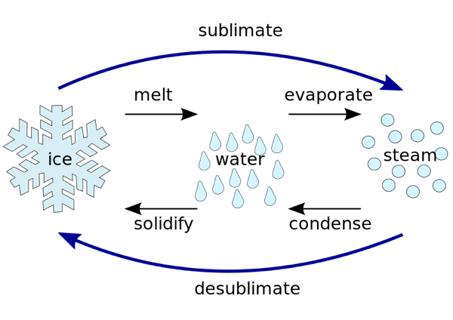

Sublimation is useful procedure for purification if the impurities are essentially nonvolatile.

The applications of this technique is sublimation printing, when sublimation inks are heated to 400 oF, they turn in to gas and form a permanent bond to 100% polyester fabric.

One of the most important factors affecting the sublimation is :

* Temperature
* Pressure

This phenomenon physical not chemical and used in freeze-drying by hanging wet cloth outdoors in freezing weather to be recovered dry at a later time.

Condition required for sublimated :

* It is vapor pressure must be high
* It must be non-ionic and non-polarized
* It must be symmetrical in shape
* The vapor pressure of impurities is low so that the impurities do not sublimate

The most well-known example of material that undergoes sublimation is:

* dry ice or frozen carbon dioxide
* iodine (produce fumes on gentle heating)
* naphthalene
* arsenic

Advantage of this technique.

1-No solvent needed to be removed.

2- Sublimation purification is faster than crystallization.

3-we can remove water molecules easily.

Purpose: to purify solid organic compounds.

Instrument and material:

• Hot Plate   
• 250 ml Beaker  
• Watch Glass  
• Weigh paper  
• Centigram balance  
• Glass Stirring rod

•spatula

•glass funnel

•Petri dish

•filter paper

•Benzoic acid

Procedure

1-weight o.5 of sample (B.A) in a petri dish.

2- Cover the sample by a wet weighed filter paper and put funnel on the Petri dish

3- Heat the sample until it sublimate.

4- Weight the pure amount of solid compound.

5-Caculate the percent of purity.

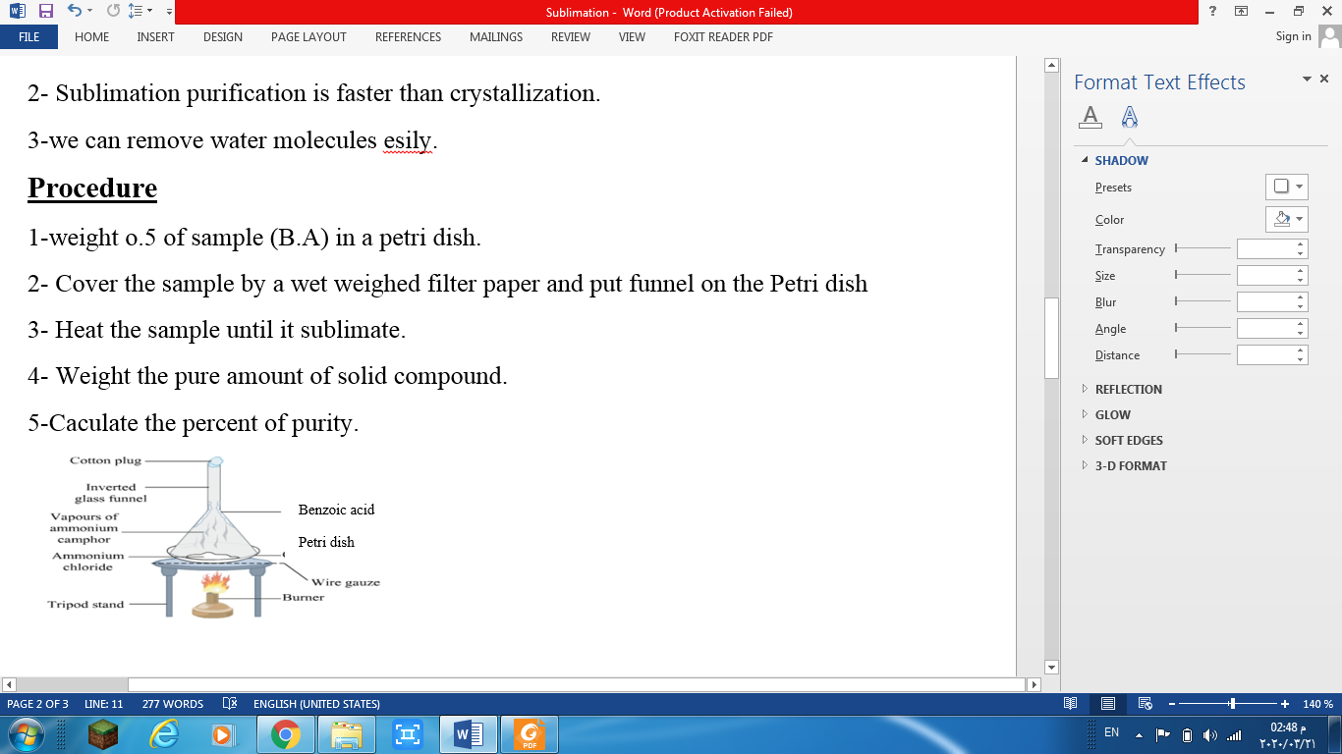

H.W